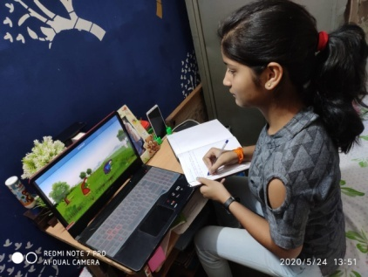  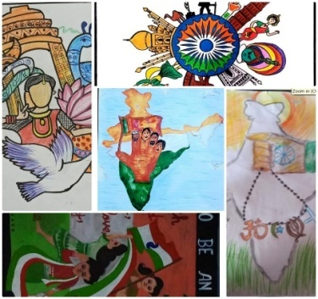  A Glimpse into the world of Mount Columbus |  | - Columbian Chronicles  - July- Sep 2020
 |  | In This Issue
- INDEPENDENCE DAY
- EMANCIPATION
- INTER SCHOOL COMPETITION
- TEACHERS’S CORNER
- STUDENTS’S CORNER

Message from the Principal
Dear Columbians
At the very outset, I would like to send you warm greetings from the school. We are going through an unprecedented global predicament today. Each one of us and the entire world is affected by the Covid 19 pandemic; our economy, our families, communities and our entire way of life are adversely affected by the scare of infection and contagion. I would like to share your anxiety and preoccupations and express my solidarity with you and your family.
To begin with, I request all of you to place on record the brave hearts who have been working tirelessly putting at risk their own life, all the volunteers, health professionals all over the world. Their selfless service is commendable. Let us in spirit wish and pray for all people who have been affected by the virus directly and indirectly. We, at Mount Columbus School, are concerned about the health and safety of our students, staff and their families and friends.
This is the moment we are called to be our best selves in tune with the vision and mission of Mount Columbus to be men and women for and with others leading a life of patience, empathy and compassion. The virus has prompted all of us to gain a heightened self-awareness. I am sure all of us have been practicing social distancing, physical distancing and coming together on social media for mutual morale boosting conversations and sharing. This is the best way to counter the pandemic.
Stay home; Stay safe!

INDEPENDENCE DAY CELEBRATION
Mount Columbus school, Dakshinpuri celebrated its 74th Independence Day with unprecedented patriotic fervor on August 14, 2020.
As the nation geared up for celebration, with Covid-19 hovering on and a lack of clarity on when schools would reopen, students opted for a virtual route to celebrate through Google Meet or similar platforms. The ceremonies and cultural programmes were organized with a ‘virtual’ twist.
The gamut of celebration activities held on the campus consisted of flag hosting done by the Principal. After that she delivered an inspirational speech in which she asked the students to stand for what is right and wished everyone to be safe and healthy.
Our school has sent messages to students and parents, informing about virtual I-Day celebrations.
Channelizing the creativity of students through an online essay writing competition, cultural programmes, drawing, singing, speech and quiz competitions were the prime concern of the school.
The students were not physically present in the school premises; however, they were connected with us via virtual platform. The programme came to an end with everyone singing national anthem together. All were happy and gay on this pious occasion.

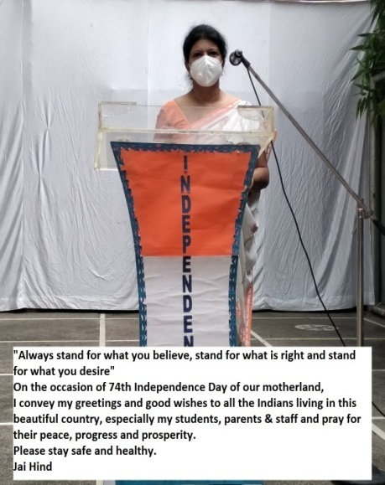

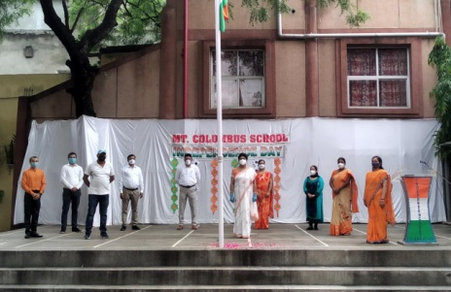
‘EMANCIPATION’

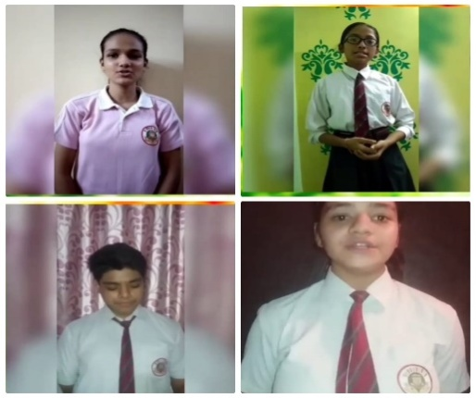
Despite this pandemic situation where everyone is staying at home, our students were participating in various Inter-House Competitions organized by the Mount Columbus School on the occasion of the 74th Independence Day with unprecedented patriotic fervor on 14th August, 2020.
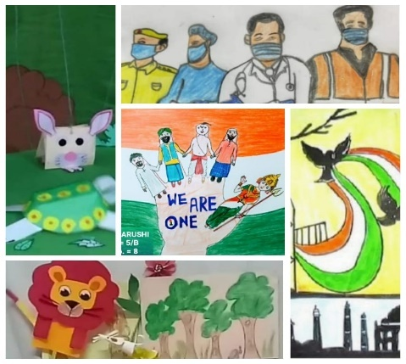
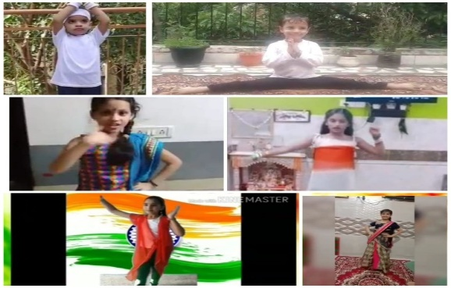
Keeping in sync with the theme, the students of Class Nursery to X participated with great zeal and enthusiasm. All the competitions were conducted online and students had shown their immense talent, imagination and creativity. The students of all the six houses were at their best. Spontaneity and confidence were the hallmark of the competitions. Class Nursery and K.G performed yoga on theme environmental postures. They dressed up in white T-shirt and trousers. Class I and II students prepared creative videos on Nation’s Hero and their famous speeches. A beautiful puppet story on the theme kindness and love displayed by the students of Class III and IV was amazing. Class V-X students participated in, Nrityakala’ competition on the theme Naman (Desh ke Jawan Ko). Eye-catchy and beautiful art (picture) on the theme ‘We Are One’ and ‘Let’s Feel Proud To Be A Glorious Nation’ were made by the students of class IV-X. Class VI and VIII also participated in Recital Competition on the theme ‘Hope’. Culture of Sikkim was presented by Class IX and X in the TECPO competition. They prepared creative e-Posters using software word/Power-point/Canva. Class VII and IX composed poem on the theme ‘Own Creation Competition. A creative power point Online Quiz competition ‘How Much I Know’ was conducted in 3 groups Class IV-V/VI-VIII and IX-X. The quiz competition comprised of 3 rounds-Be quick, audio-visual and Picture-musical. Last but not the least ‘My Message’ an open for all Competition was conducted for all students on the theme Proud moment for you as Indian.
The participants of all the six houses participated whole heartedly in this event. Though each and every one has put in their best effort the first position was bagged by Amazon House, second by Nile house, Indus and Thames bagged third position
The Emancipation was a success. It was successful because the students enjoyed these competitions thoroughly. It was fun and learning for them. The effort of the students was appreciated by all.

‘आवेणिक २०२०’ : Inter - School Competition
‘Providing a competitive environment and generating integrity, develops our children’s intelligence and enhance their creativity ‘
Mount Columbus School has set the benchmark for conducting activities in such a way that the students not only enjoy but also learn a great deal from it. With the same perspective, the inter-school competition was held in commemoration of our freedom fighters in the month of August 2020 and unfurled the patriotic feeling among one and all. The school witnessed an ample of online activities organised by our social-science department under the guidance of our honourable Principal ma’am, for the class VI to XII.
The registration for the competition started on 8th August 2020 and the last date for submission of activities was on 14th August 2020. The details of the competition are as follows.
S.No. | Class | Theme
1. | VI | Heroes of the Nation (Poster Making)
2. | VII-VIII | Historical Monuments ( Picture from waste material)
3. | IX-X | Master Chef ( Tricolor Mocktail)
4. | XI-XII | Atmanirbhar Bharat ( Self – Composed Poem)
Students from various schools of India participated enthusiastically in this competition. Students were asked to send their activities through email in PDF form or videos as required.
The participants were judged on the basis of theme, creativity, overall presentation, aesthetic skills, innovative ideas, content etc. The judges were invited to give their fair judgement in the competition. The result of the competition was published on 21st August 2020. The results of the competition are:-
Class VI : Theme – Heroes of the Nation
Position | Name of the Student | Name of the School
I | Avni Tandon | Vivekanand School D-Block, Anand Vihar, New Delhi
II | Sajoli Shree | ASN Senior Secondary School, New Delhi
III | Aamisha | DAV Public School Vasant Kunj, New Delhi

Class VII-VIII : Theme - Historical Monuments
Position | Name of the Student | Name of the School
I | Mitul Gupta | Vivekanand School Anand Vihar, New Delhi
II | Sanskriti Guhapramanic | Mount Litera Zee School Maheshtala, West Bengal
III | Samyukta Katari | Manava Bharti India International School Panchsheel Park, New Delhi
Class IX –X : Theme-Master Chef
Position | Name of the Student | Name of the School
I | Roshni Raut | Techno India Group Public School, Konnagar, West Bengal
II | Mansha Malik | Vivekanand School , New Delhi
III | Pranay Behl | G D Goenka School Rohini, New Delhi

Class XI-XII : Theme- Atmanirbhar Bharat
Position | Name of the Student | Name of the School
I | Liza Sharma | Vivekanand School Anand Vihar, New Delhi
II | Samyank Kumar Singh | Sant Nirankari Public School Nirankari Colony, New Delhi
III | Arpita Sharma | Vivekanand School Anand Vihar, New Delhi

All the students were at their best, spontaneity and confidence were the hallmark of the competition. All the participants were awarded with the E-certificate of participation and all the position holders were awarded with E-badges.
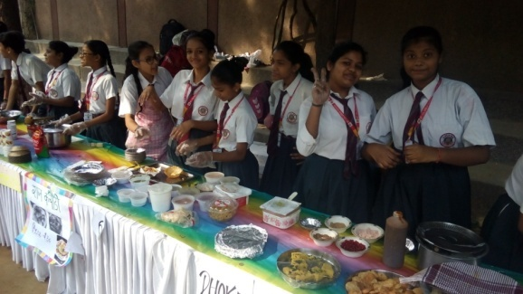
In a nutshell, all the students showcased their creativity and artistic skill and revealed their hidden talent. This was not just an event for us, organising such activity is actually a proud feeling for all of us. This event was successful as students from various schools participated in a good number. We thank our respected Principal Ma'am - Ms Aditi Roy, who gave us this opportunity and platform to conduct this activity.

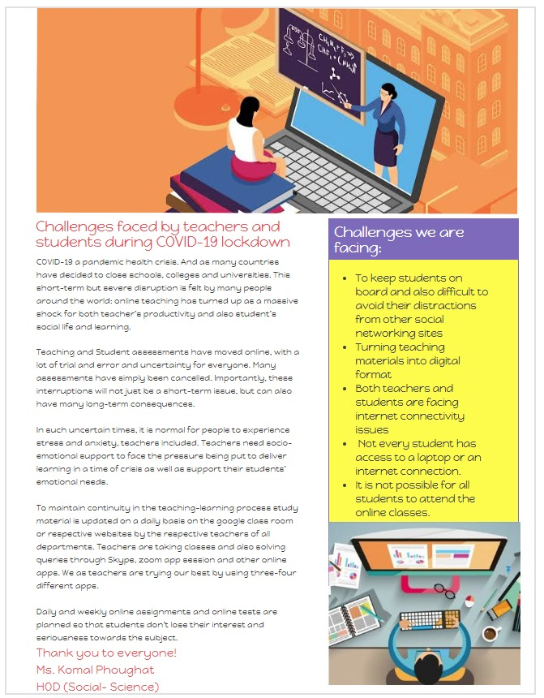
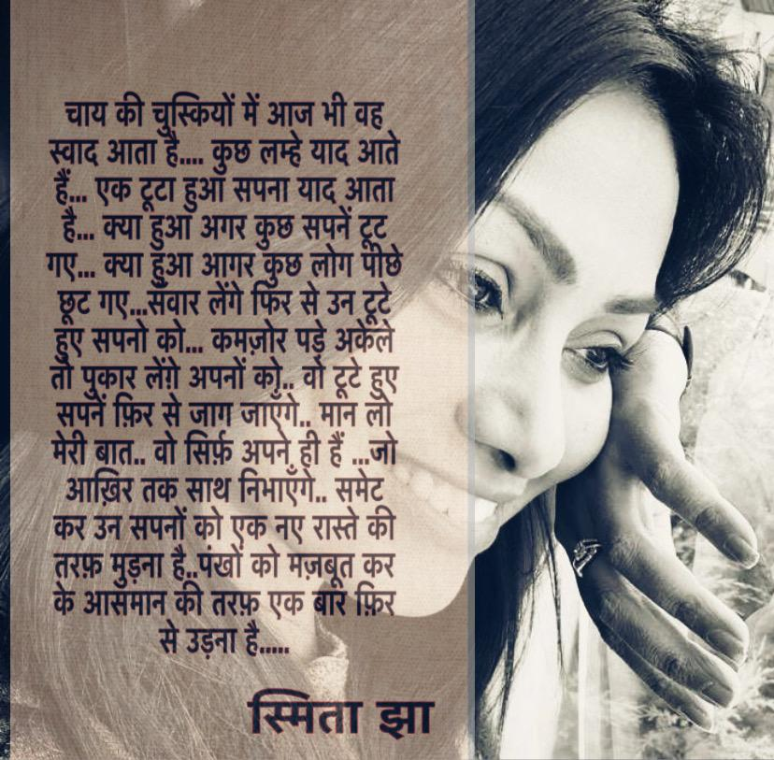
COVID CHALLENGES AS A TEACHER
Due to the spread of Covid-19, schools were shut down at the beginning of the session- 2020 as the safety of life is foremost than anything else. The country passed through many lockdowns but teachers continued to connect with their students and impart education through online classes.
This is the first time in the world when such a situation has raised where teachers and students had to adopt technology without any preparation. Online teaching requires distinct skill sets that are not a part of the teacher’s training curriculum but they have taken it positively as this is the demand of time. Adapting to online education is difficult for the families where there is more than one child. Parents faced the problem to provide gadget to all children while some did not want that teaching should be done online but gradually, they understood that this is the only way to continue the studies of their children.
Developing a cordial relationship with the students through virtual classroom was one of the biggest challenges for the teachers.
To keep a track of each student by virtual classroom increased the pressure on teachers.
Someone rightly said that “Teacher's job is full of challenges, not only to prepare students for anything, but their job is to help students prepare themselves for everything”.
Ms. KANCHAN MASIWAL

Life is not about being witty ,
Not everything is in our Kitty,
Today's life is nothing but only pity,
As we are losing our precious Biodiversity.

Nature is having various species hierarchy ,
With lots of flora and fauna variety,
An important thing for the world community,
It's our valuable biodiversity.

We are weakening our immunity,
Not even thinking about our capacity,
Making a life full of perplexity,
We’d immensely harmed our Biodiversity.

There's always an opportunity,
Life is having its own peculiarity,
If we all join our hands with humanity,
We all can regain our Biodiversity.

Nature has its own intensity,
This pandemic has already weakened our immunity,
We can overcome it only by showing Unity,
We need to save our Biodiversity.

Community needs prosperity,
Prosperity needs generosity,
Generosity need serenity,
Serenity needs eternity,
Firstly, We all need our Biodiversity.
MS. KHUSHBOO SEJWAL

फ़र्क पड़ता है
फ़र्क पड़ता है उस हर चीज़ से,
जो मेरे आस-पास हो रही हैं कहीं
फ़र्क पड़ता है मुझे उन सबसे,
किसी ने हाथ धोया या नहीं।
फ़र्क पड़ता है उन सब लोगों से,
जो पलायन करते नज़र आ रहे हैं
कहीं
फ़र्क पड़ता है उन सब बच्चों को देखकर,
जो कभी गलियों में शोर मचाते थे
अब कोने में बैठे हैं कहीं
फ़र्क पड़ता है यह सोचकर,
हालात और न बिगड़ जाएं कहीं
फ़र्क पड़ता है यह सोचकर , आज कितने लोग भूखे बैठे होंगे कहीं
फ़र्क पड़ता है उनके लिए जो
बेख़ौफ़ काम करते नज़र आ रहे हैं कहीं
फ़र्क पड़ता है यह सोचकर कि ये गुलसिता मुरझा जाए न कहीं
फ़र्क पड़ता है जनाब ...........
मधु ठेनुआं

