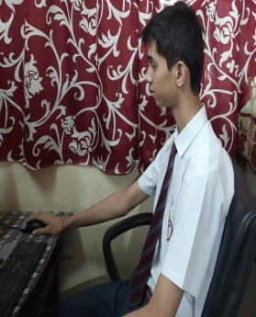  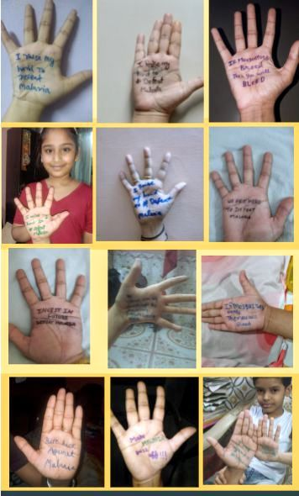  Type Tagline Here  A Glimpse into the world of Mount Columbus
    - Columbian Chronicles
    - AprIL-june 2020
Online classes in Mount Columbus School  Waking up to morning alarm, getting ready , slipping on an ironed attire ,  eating breakfast and then hurriedly rushing to reach to the school on time. …  all these have hit the pause button ever since the lockdown.  Mount Columbus School has replaced traditional classrooms with virtual classes to continue the studies of our students during lockdown. The New Session began for the classes VI to X on 26th March 2020, for the classes KG to V from 1st April and for Nursery from 3rd April 2020. Class Teachers started making class groups on WhatsApp, in which they added all the students and the respective subject teachers and informed them about the time table to be followed. Every day the online session starts with prayer and workout sessions by ‘Fit India Movement’ followed by the attendance. All the teachers are pouring their efforts to elaborate the topics by making PPT’s, Pdf’s and videos to make the topics more clear to the students and to retain the interest of students in virtual classes. Teachers also send voice notes to discuss and clear the doubts of the students.  Despite of all the hurdles due to the pandemic, teachers and students of Mount Columbus School are trying to making these classes a successful attempt of learning. |  | In This Issue
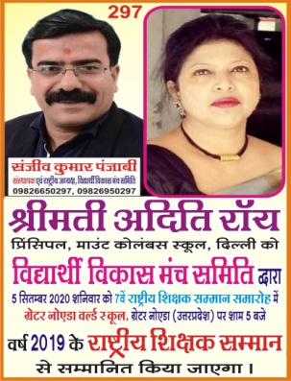


Message from the Principal
Dear Columbus Family
It is with great pleasure that I welcome you to the 2020-21 school year.
Today, the role of a school is not only to pursue academic excellence but also to motivate and empower its students to be lifelong learners, critical thinkers, and productive members of an ever-changing global society.
Last school year was the most successful one at every level; academically, athletically and as a school community.
Looking back at our previous school years we have so much to celebrate and be thankful for! Our staff, students and parents helped our school to grow.
It is rather a tough beginning for all of us as we are stuck in the pandemic (Covid – 19). But we at Mount Columbus School are always ready to help our students. We assure you all that your kids are in safe hands and the staff of the school will make every little effort to ensure that the students are not deprived of the studies at any cost.
Looking forward to be our best in this session too with your support.

- ONLINE CLASSES
- ENGLISH LANGUAGE DAY
- MALARIA WEEK
- MOTHER’S DAY
- ACHIEVEMENT
- BIODIVERSITY WEEK
- AUGMENTED LEARNING

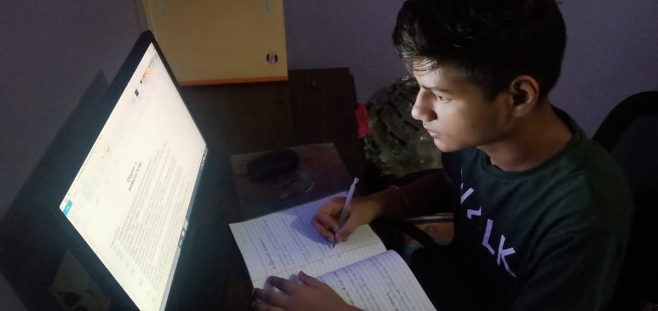

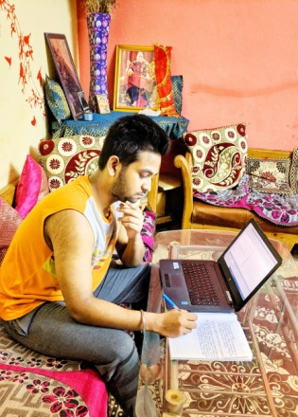
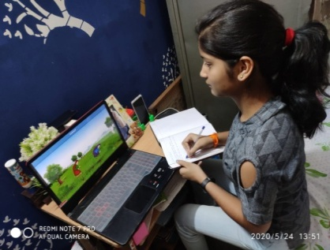

ENGLISH LANGUAGE DAY

Happy English Language Day!
English Language Day is a United Nations (UN) observance that people celebrate on April 23 each year. It coincides with William Shakespeare’s birthday and World Book and Copyright Day.
English Language Day aims to entertain and inform people about the history, culture and achievements associated with the language to promote it.
Mount Columbus School celebrated English Language Day with a bash of creative fervour despite lockdown. English is the Lingua Franca of the modern era and lockdown could not fade the celebrative spirit of school.
The activity was not only pleasurable and engrossing but was quite informative as well. First we came to know about different other books our co- teachers are reading. The best part was the active participation of all the teachers to encourage and add perusal colours to the day. Hope to celebrate forthcoming English Language Day with more enthusiasm and creative activities.

MALARIA WEEK
Despite this pandemic situation where everyone is staying at home, our students were busy doing their activities organized by the Science department on the Malaria week from 1st to 7th May 2020. These activities were conducted online and students had shown their immense talent by collaborating on WhatsApp. The objective was not only to inculcate the scientific attitude and creativity but also to increase self-awareness, develop critical thinking and socio-emotional connect among the students.
Keeping in sync with the theme, several activities were organized for the students like - role-plays and fashion shows using their handmade masks and props. They dressed up as a mosquito, making creative bookmarks with a short message to drive awareness against Malaria. Colorful mosquito mask-making craftwork was displayed by the students. All of these activities were aimed at creatively spreading awareness. Eye-catchy and interesting cartoon art on preventive measures of malaria, fun facts on mosquito, article on the mosquito repellent plant, family pledge picture for the malaria-free world, all the above were also prepared by the students. Young scientists made pamphlets on mosquito repellant cream and spray. They wrote poems, and songs for spreading awareness. Survey reports on Malaria in different states of India and the 3D model of the life cycle of mosquito were beautifully presented by the students and they also represented themselves as responsible reporters and delivered updates and analysis on Malaria.
It was fun and learning for the students. The efforts of the students were appreciated by all.



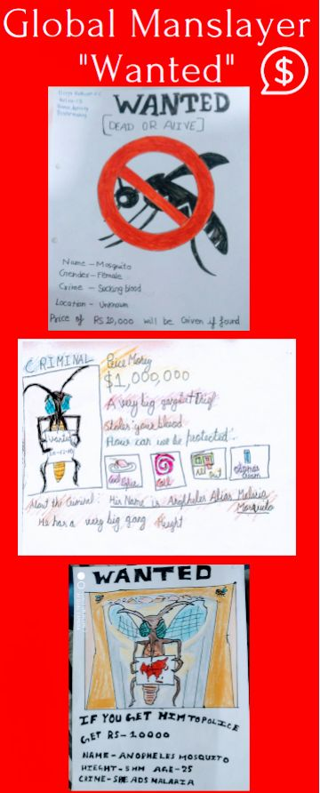

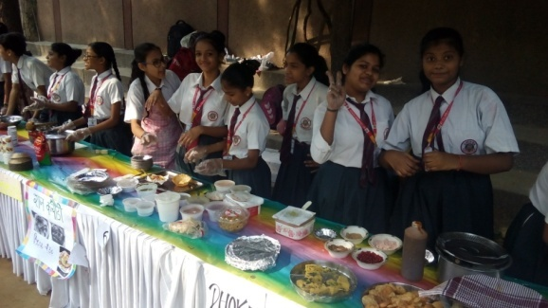
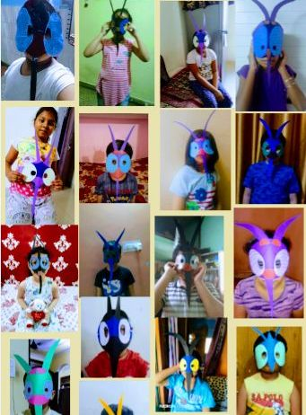

MOTHER'S DAY
Our school organized Mother's Day on 10 May'2020 and conducted some interesting activities on this occassion. Due to the pandemic spread all around the world. All the teachers had designed a beautiful activity sheet for the students so that students can show respect and express gratitude towards their mother. Following activities were given to the students, which they had performed on the Mother's Day: Making bed tea, giving flowers and wishing their mother, clicking photographs, singing songs, poem recitation, giving foot massage, helping in household chores, baking cake, making cards, cooking without fire etc. Students took part actively in the activities and showed their love for their mothers. Students sent their lovely videos and photographs of Mother's Day Celebration to their class teachers. Teachers acknowledged the efforts of all the students.

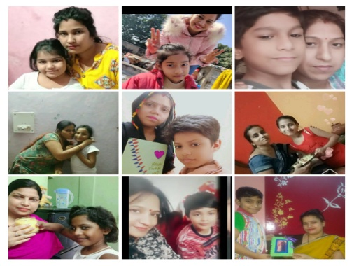
ACHIEVEMENT
With great pride and honour, we announce that our esteemed Principal mam has received the ‘Rashtriya Shikshak Samman 2019’ award by ‘The Vidyarthi Vikas Manch Samiti’ taking the name of Mount Columbus School to yet another level.

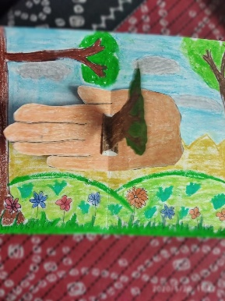
AUGMENTED LEARNING

A Webinar was attended by three students of Mount Columbus School on 23rd May, 2020 on 'Augmented Learning'. It was a live session where many students and teachers interacted with each other and learnt that Augmented Reality makes learning more engaging and fun. It also allows the learners to focus more on practical than on theory. All the participants gained more knowledge about Augmented Learning and its usage in different fields, its application, examples etc.

BIODIVERSITY WEEK

Despite this pandemic situation where everyone is staying at home, we made our students indulged in productive work so as to make them and their family members aware about the biodiversity which was organized by the Science department in the Biodiversity week from 18th to 22nd May 2020. These activities were conducted online and students showed their immense talent by being in continuous touch by WhatsApp and Zoom. The objective was not only to inculcate the scientific attitude and creativity but also to increase self-awareness, develop critical thinking and socio-emotional connect among the students.
Keeping in sync with the theme, several activities were organized. The students from Class III to X participated with great zeal and enthusiasm. Activities were provided section-wise and students were encouraged to use waste material and discouraged to go out of home in order to follow the government guidelines. Class VI made water feeder, animal wind chime, terrestrial and aquatic life of animals, nest. Class VII students became zoologist and botanist and pen down their thoughts about diverse arrays of plants and animals, made biodiversity tree, showed up their creativity by preparing stamps, logos depicting animals on them and cards popping out the message that ‘Solution in our hands’. All of these activities were aimed at creatively spreading awareness. Class VIII students prepared ‘Red Data Book’ showing extinct, endangered, vulnerable species and steps of govt towards these species and cartoonist stories on biodiversity. Slogan Holder depicting that by standing together we can make a difference in saving the biodiversity, Timeline Review in order to show that in the course of time how much difference has been seen in the biodiversity, Biodiversity wheel was created by students in unique and different manner to show conservation, loss of biodiversity and diverse arrays of species including flora and fauna by Class IX. A zoom session was held of class X in which they participated very actively and successfully presented a Ted Ex talk on the topic ‘Biodiversity’ and merged videos in as innovative way as they can which was appreciable and eye pleasing for all of us.
The Biodiversity week was a success. It was successful because the students enjoyed and participated actively. It was fun and learning for them. The effort of the students was appreciated by all.

